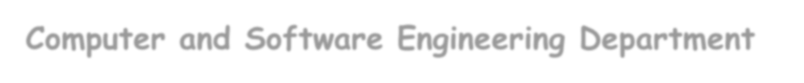

**TOROS UNIVERSITY**

**Computer and Software Engineering Department**

**SCE-216 Web Programming 2**



**Lecturer: Asst. Prof. Dr. Maryam Eskandari**

Duration: 60 minutes

. . . . . . . . . . .

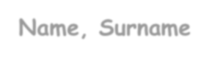

**Name, Surname**

**Student ID #**

. . . . . . . . . .

Grading:

|  |  |
| --- | --- |
| ***Q1.*** | ***/*** |
| ***Q2.*** | ***/*** |
| ***Q3.*** | ***/*** |
| ***Q4.*** | ***/*** |
| ***Q5.*** | ***/*** |
| ***Q6.*** | ***/*** |
|  | |
| Total | |



 ~~Plea~~se, check your exam sheet and make sure that it contains **6**

**questions** .In case of **any missing pages**, **inform the ** **invigilator** IMMEDIATELY !



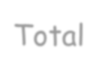

1. **How can the index.php script access the email form element of the following HTML form?**

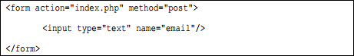

Answer:

1. **What is the purpose of using sessions in websites? In order to remove all global session variable, which PHP expression should be used?**
2. **How to write PHP code to create connection to a MySQL database named ‘lettergrade’?**
3. **Write one SQL statement to create a simple table employee including ID, NAME and SALARY, where the length of ID is 10 o, NAME is .**
4. **Write complete PHP code to delete all students with grades less than the value that user enter the**

textbox, from table ‘student’ of ‘mydatabase’ database using a textbox and button, show your deleted items into a textarea using method POST.

1. **Write a complete PHP code to check the sign of next cell of each array cell. If it is positive change it to the negative and vice versa using a function.**

Input: (1, -2, -3, 4, 5, 6, -7)

Output: (1, 2, 3, -4, -5, -6, 7)